Dining Butler
OFFLINE POS
INSTALLATION GUIDE

VERSION: 1.3

Revision History
This portion will be used when the document revision is made
# | Version / Date | Description of Change
1 | 1.0 / 04-Dec-2018 | initial
2 | 1.1 / 05-Dec-2018 | Add OfflineSync.exe on startup
3 | 1.2 / 22-Jan-2019 | Add setupPOS & Windows controller
4 | 1.3 / 24-Jan-2019 | Modify the setting for task scheduler

Step-by-Step Installation Instructions
Following are step-by-step instructions for installing Dining Butler Offline POS.

- (IMPORTANT!) Set computer date & time to use country timezone
Before run the installer, you need to make sure that the date & time settings are correct.
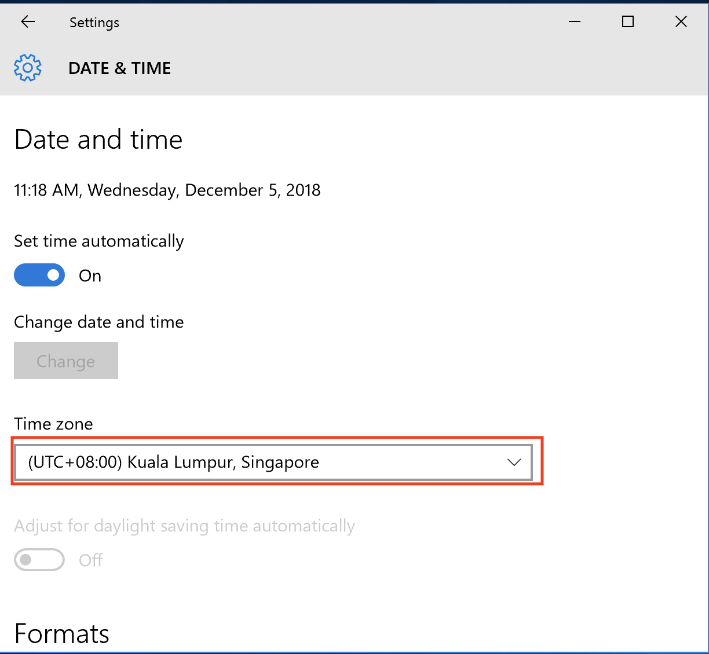
Right-click the date & time at bottom right of the desktop, then choose ‘Adjust date/time’
Choose your time zone, and make sure the date-time is correct.

- Set router DHCP to reserve IP Address for the local server

- For convenience, allow folders to see file extension
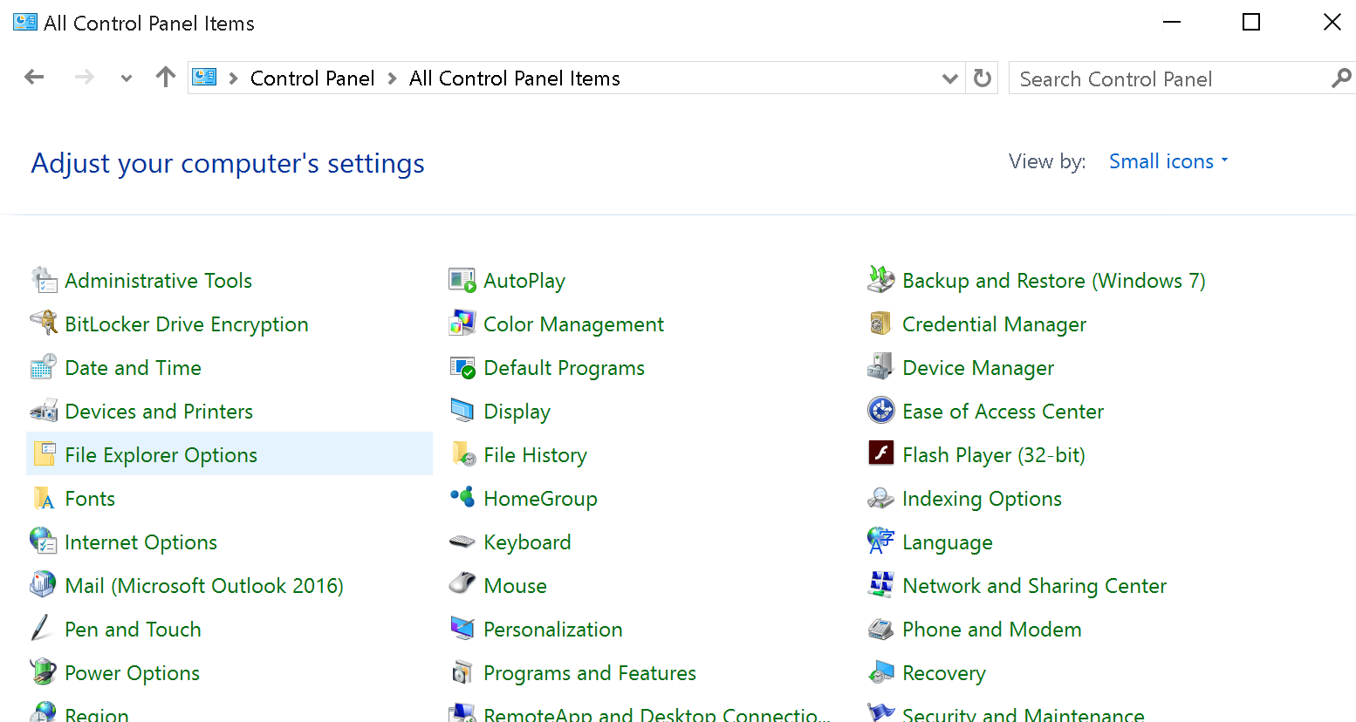
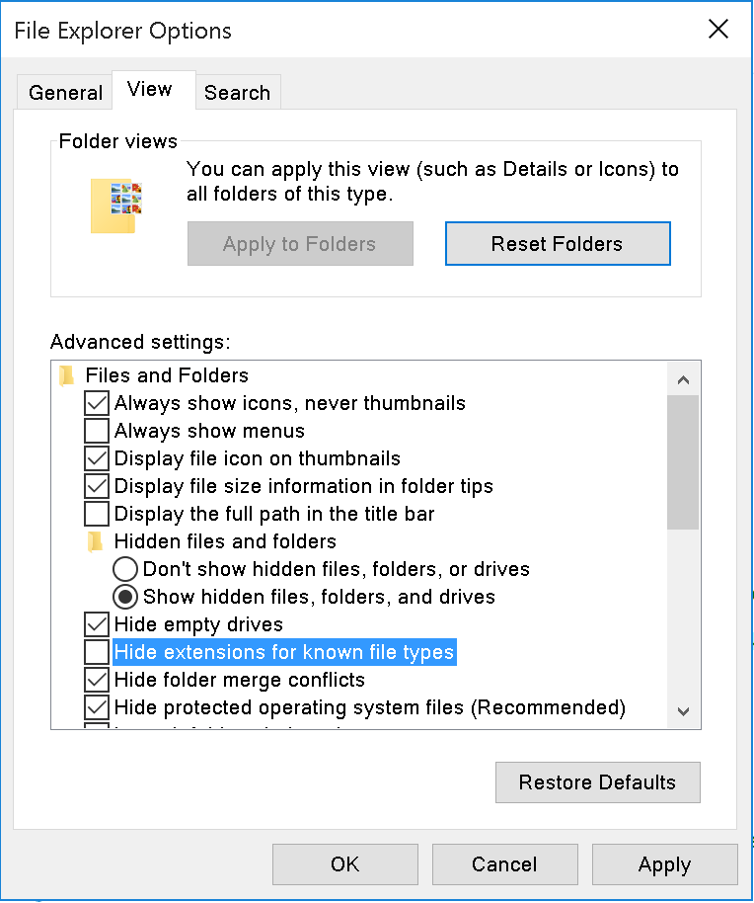
Go to Control Panel > File Explorer Options, on tab ‘View’ un-check option ‘Hide extensions for known file types’, then click ‘OK’

- Run “Setup_DB_Offline_POS.exe”
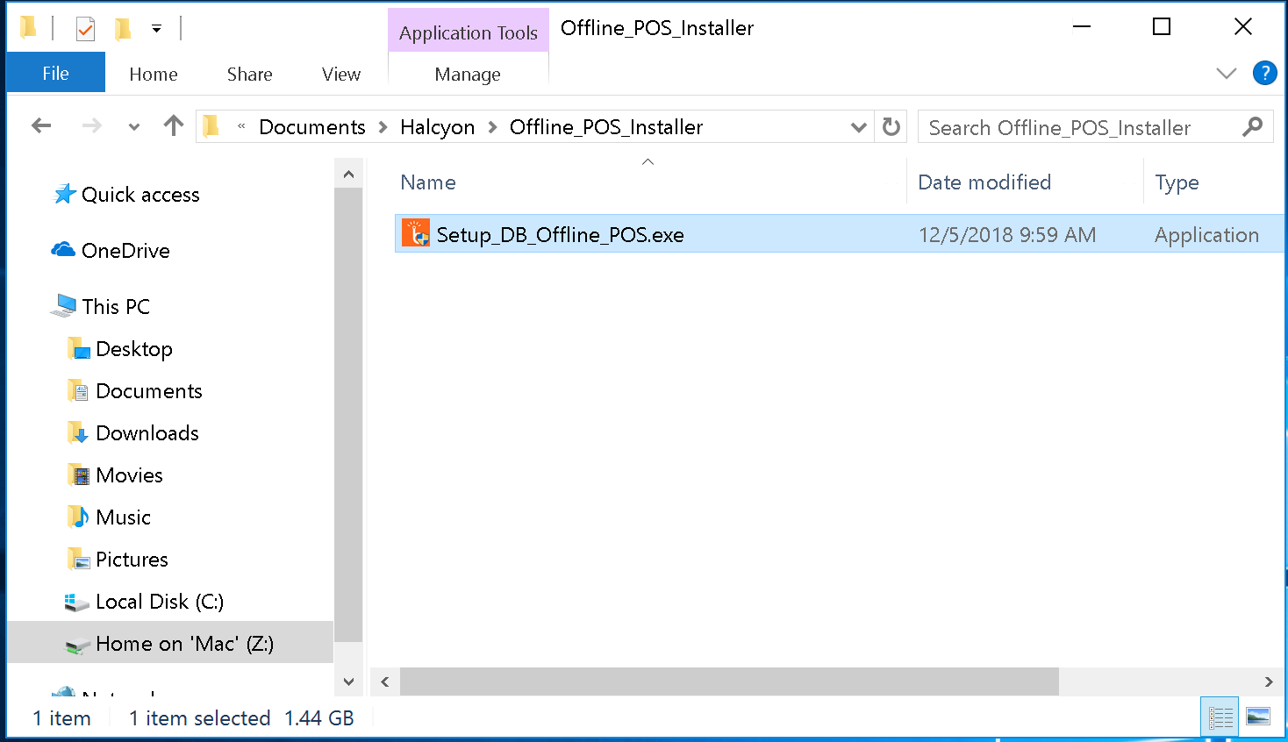
You should have saved the file somewhere on your computer. Find the file, and double-click to open it. NOTE: Please run the appropriate installer, if the computer is 64bit, please use 64-bit installer, otherwise please use 32-bit installer

- Handle the security warning, if it appears
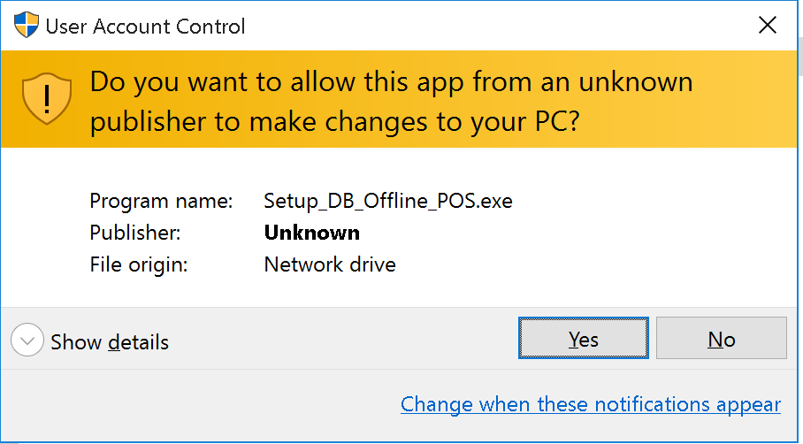
Depending on your Windows security settings, you may get a security warning:
If you do get a security warning like the one shown above, click the "Yes" button to continue with the installation.

- Follow the steps of the setup wizard
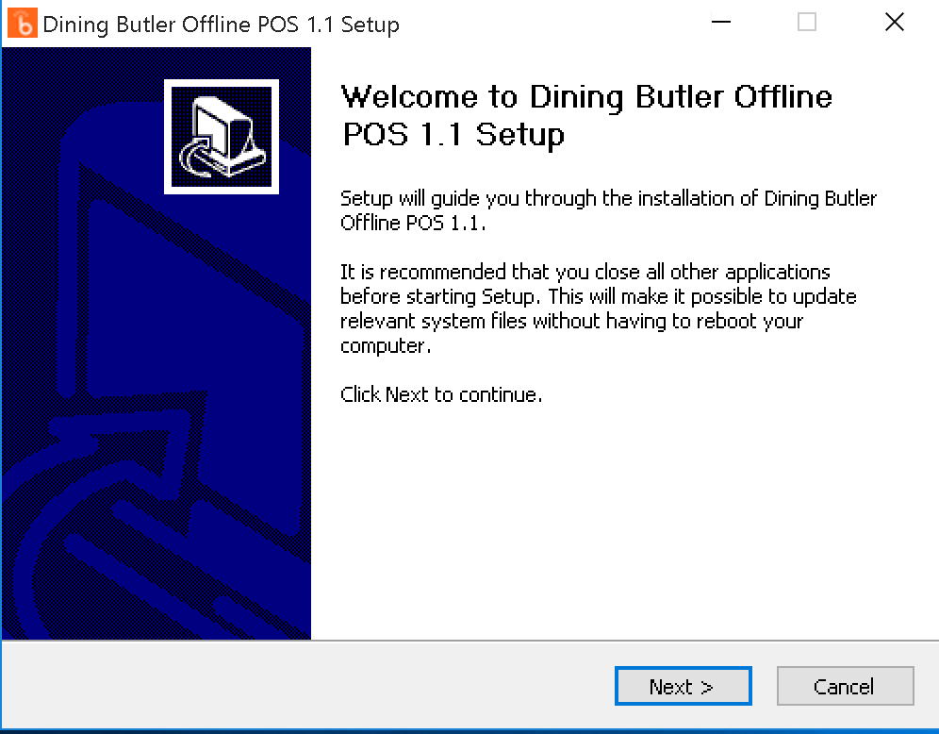
The setup wizard should automatically start to load. The first screen is shown below:

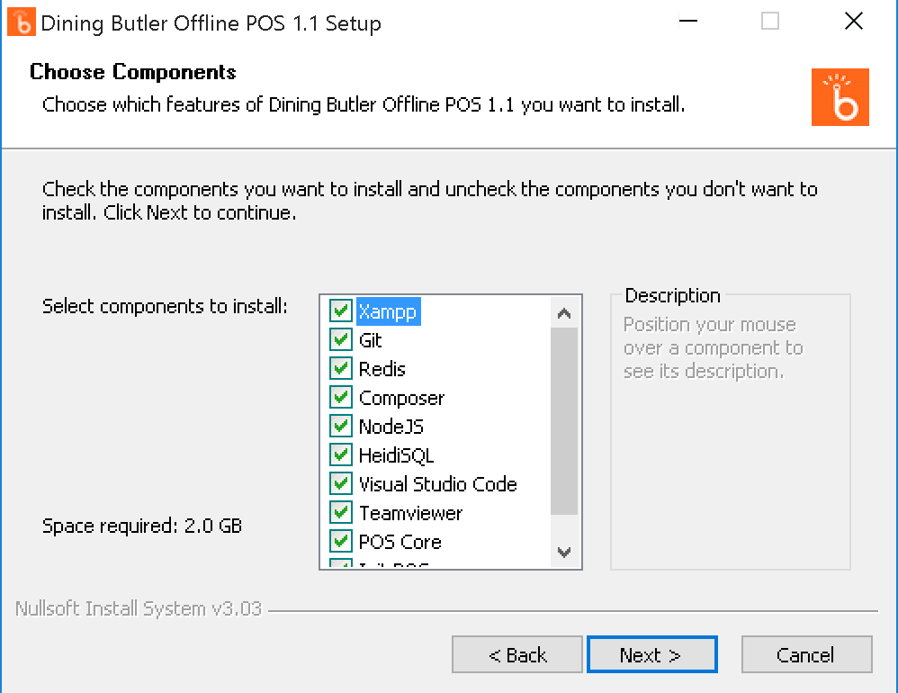
Click “Next >" to continue to the next screen. The components list screen will be shown as below:

Click “Next >” to continue to the next screen,

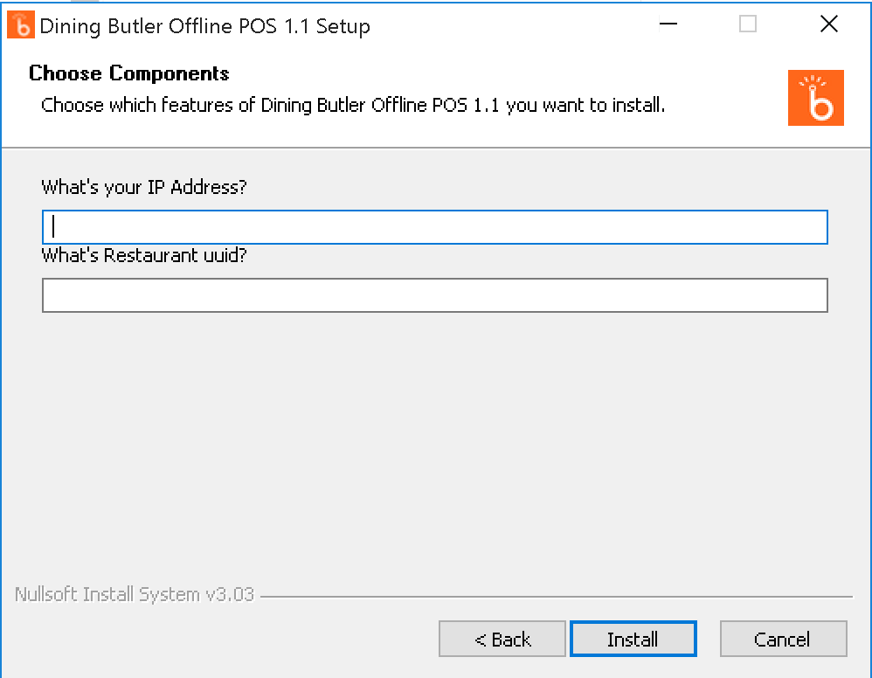
Put the IP Address (e.g: 192.168.0.100) and Restaurant uuid (e.g: 00000000000154R0000000000000000154000000), then click “Install”.
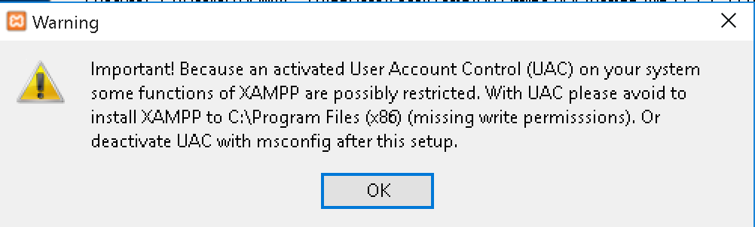
The installer will process to install the softwares
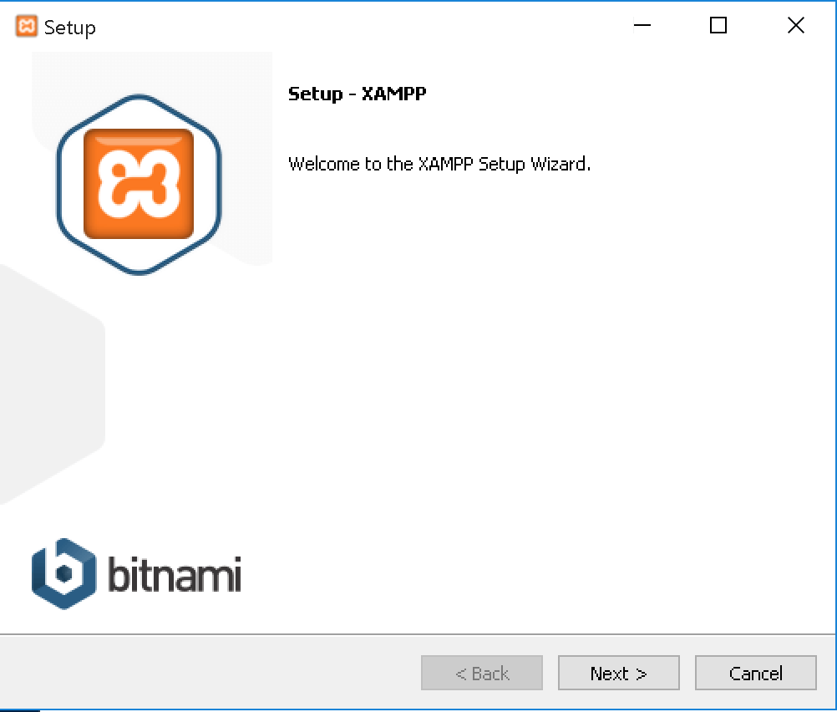
If you get the warning like the one shown above, click “OK”
Click “Next >”,
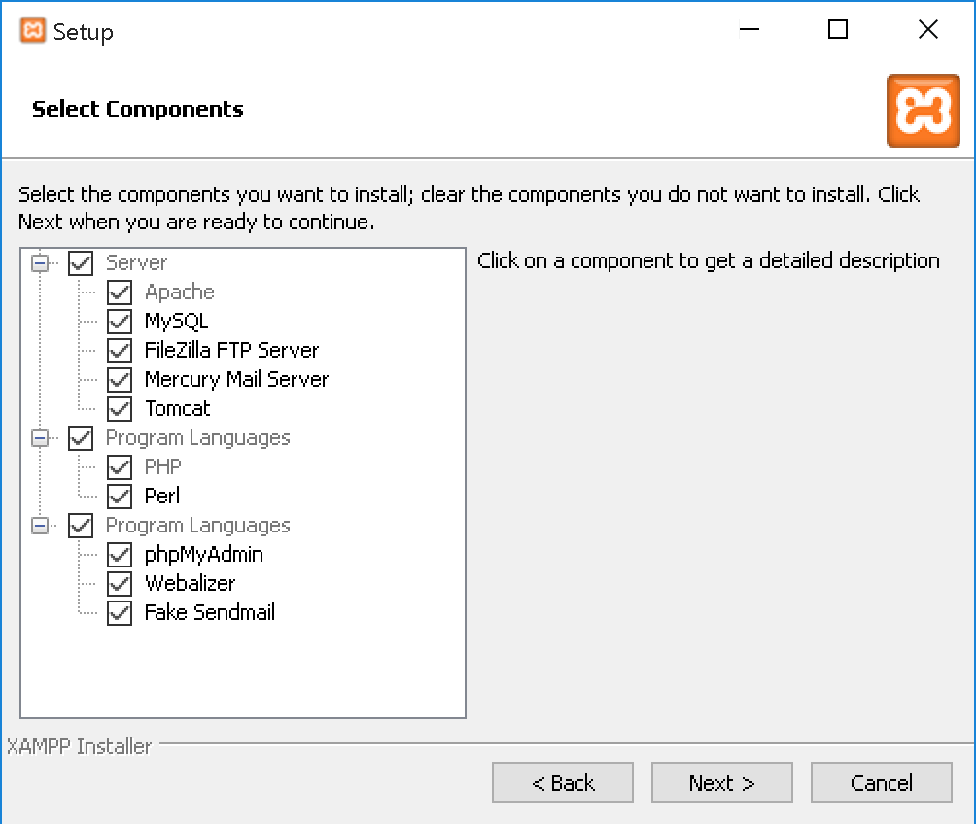
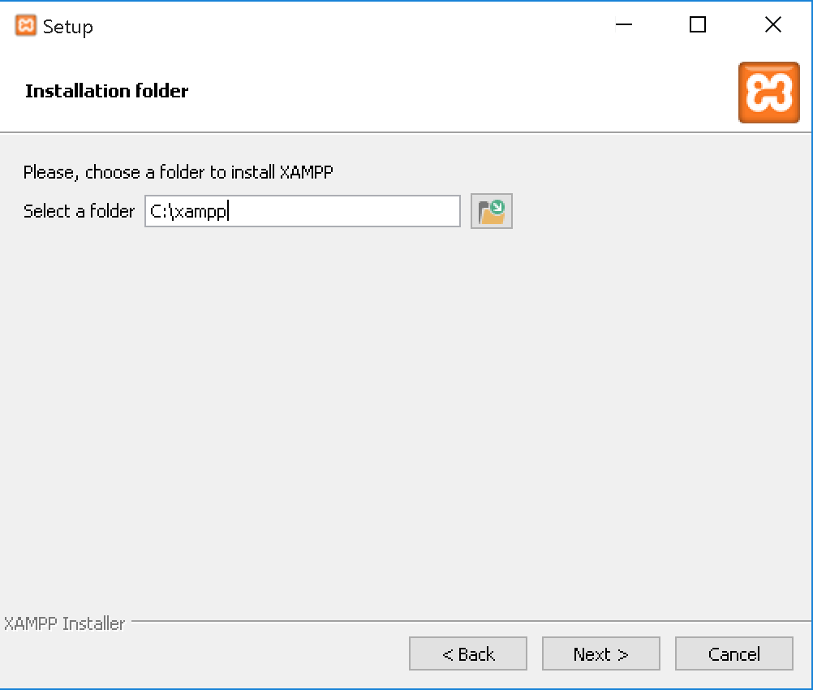
Click “Next >”,
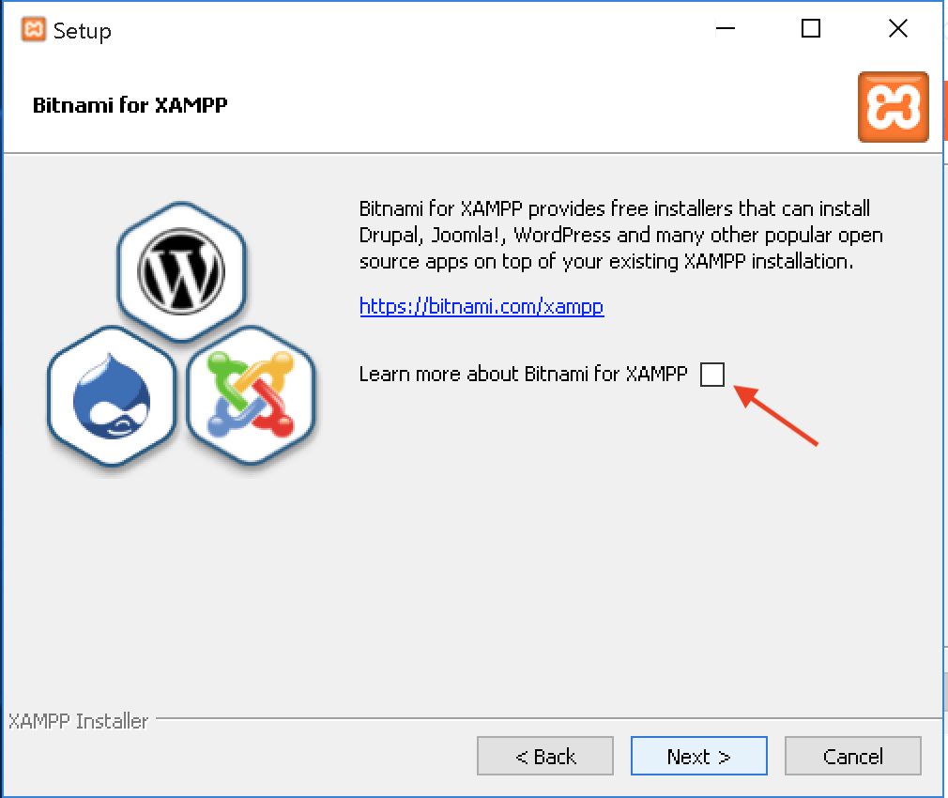
Click “Next >”,
“Untick” the option, then click “Next >”,
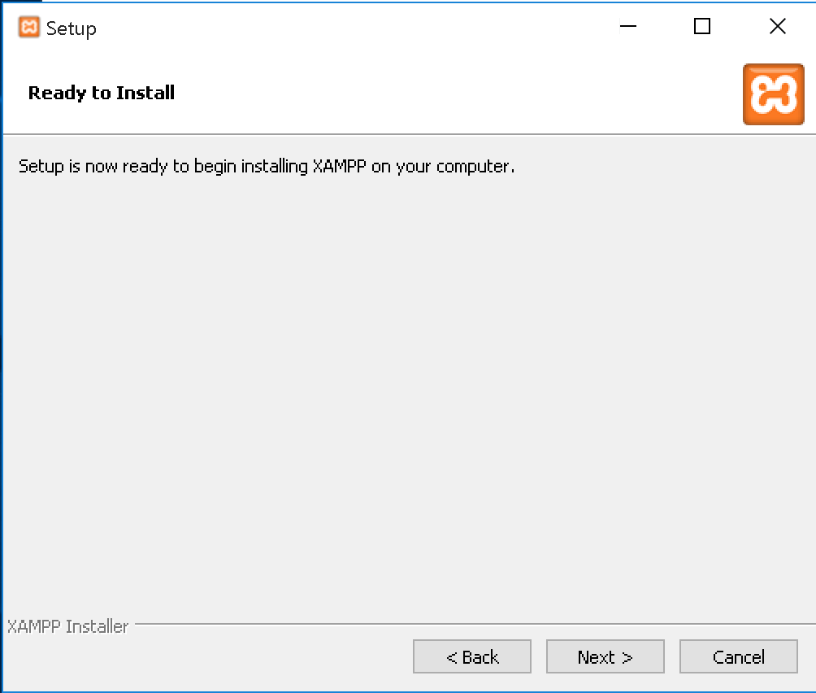
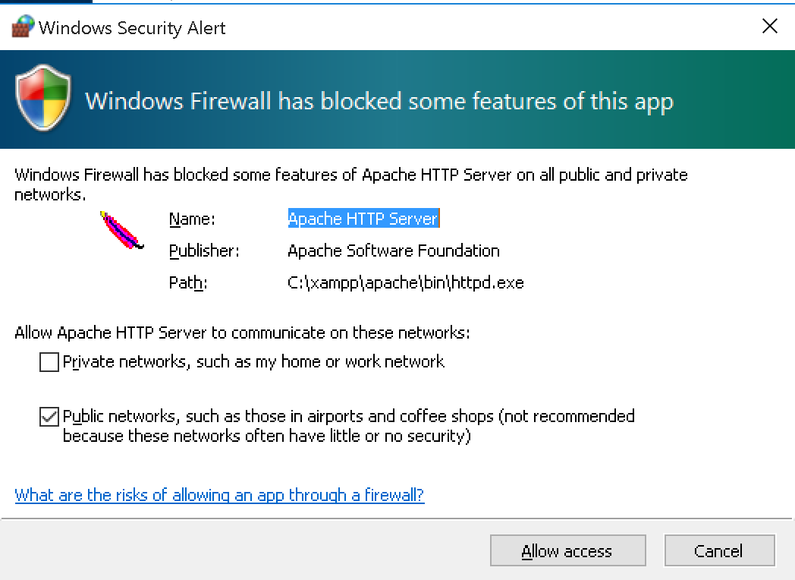
Click “Next >”, then xampp will processing the installation.
If you get the warning like the one shown above, click “Allow access”,
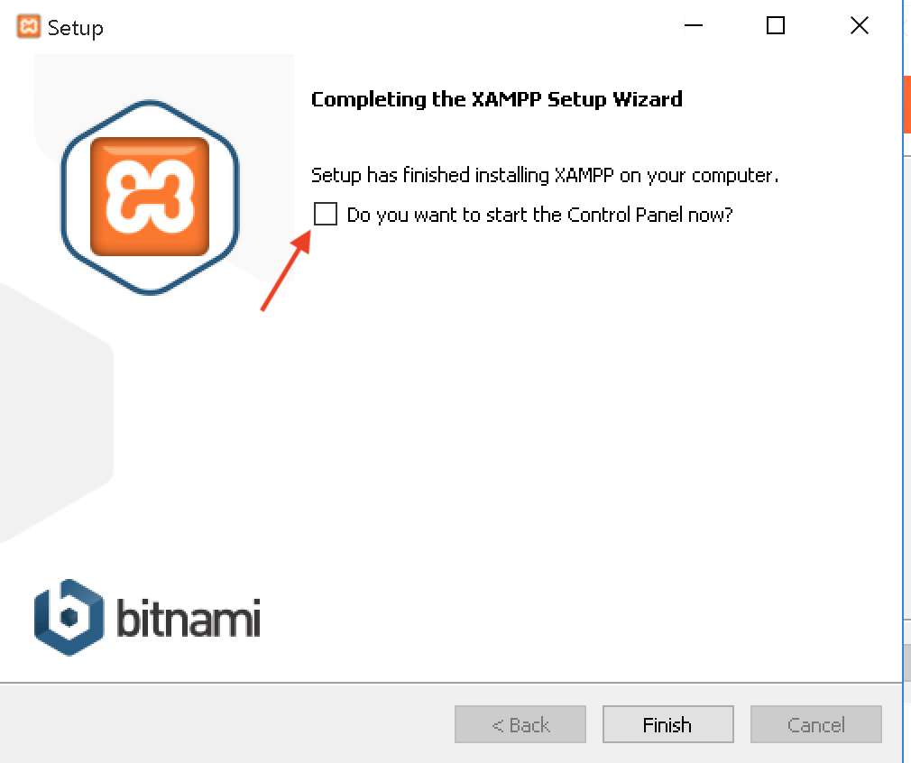
“Untick” the option, then click “Finish”,
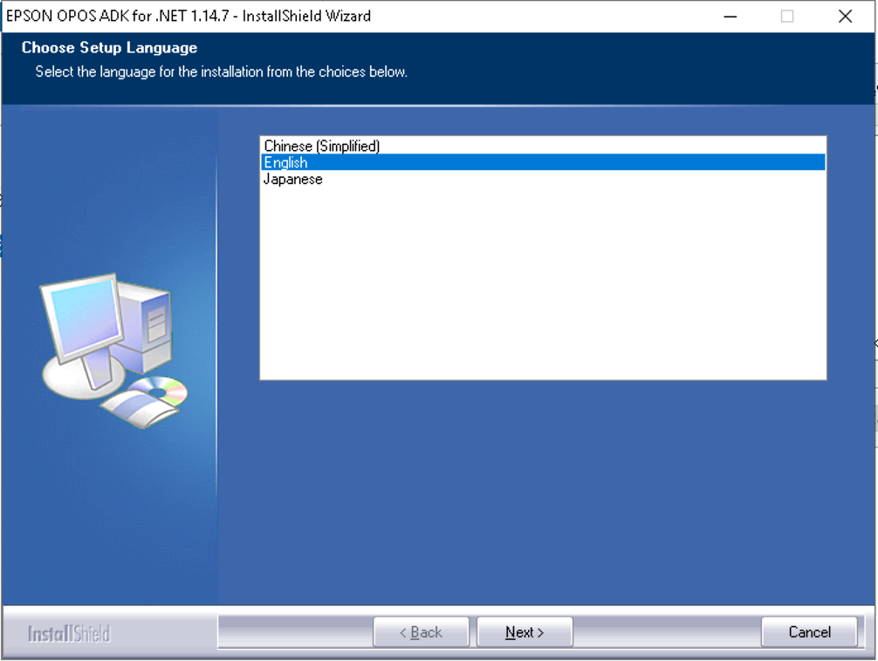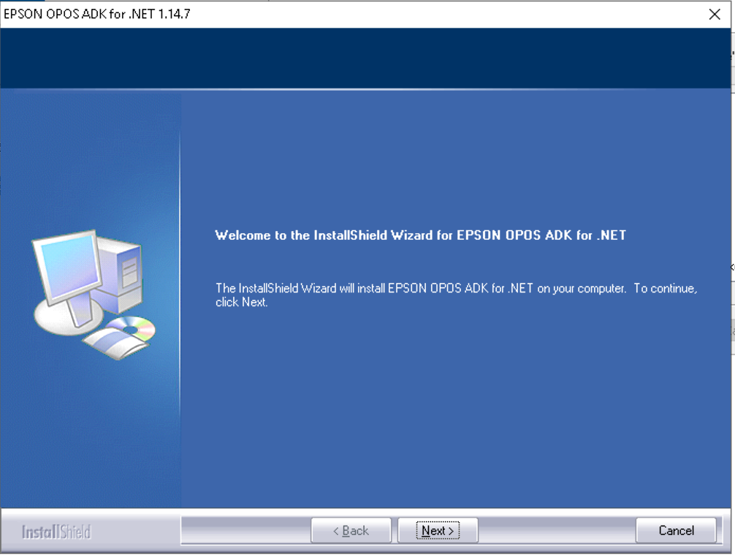
Click “Next >”, “Next >”,

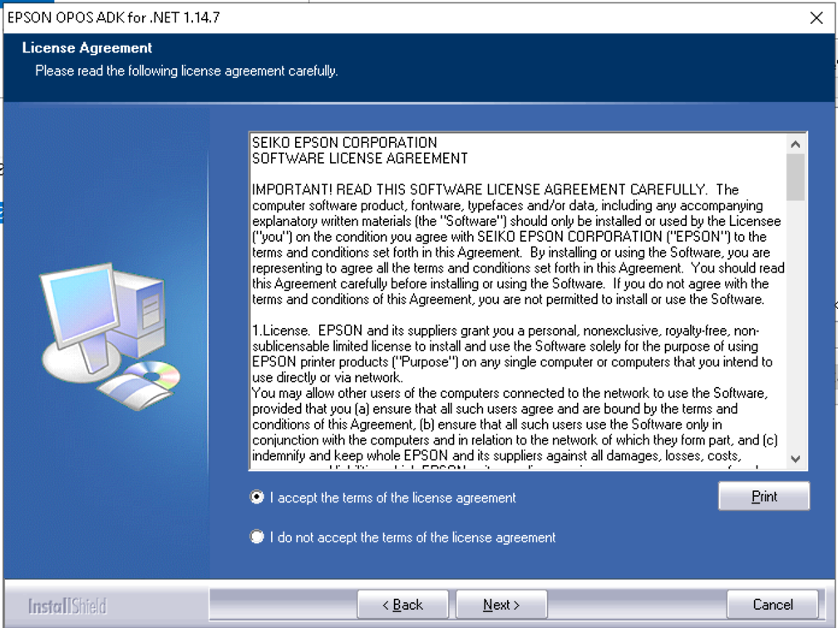
choose “Accept” , then click “Next >”

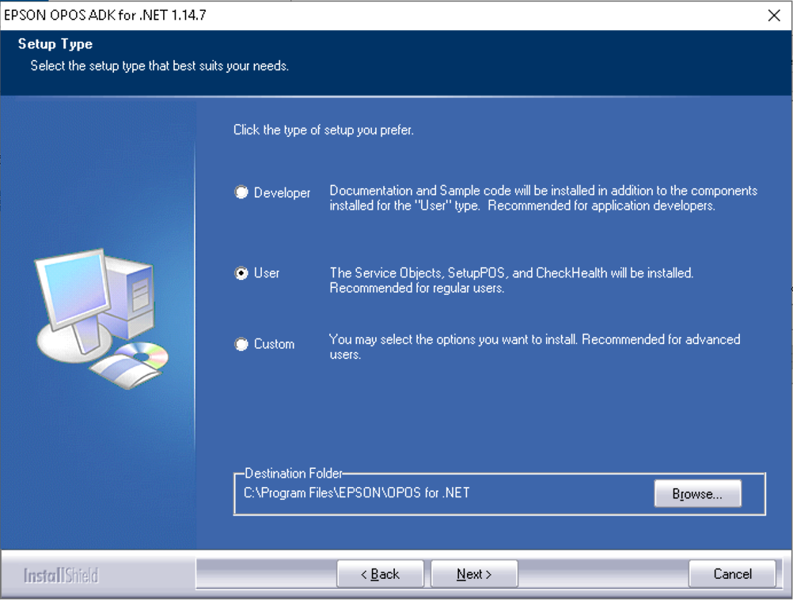
choose “User”, then click “Next >”

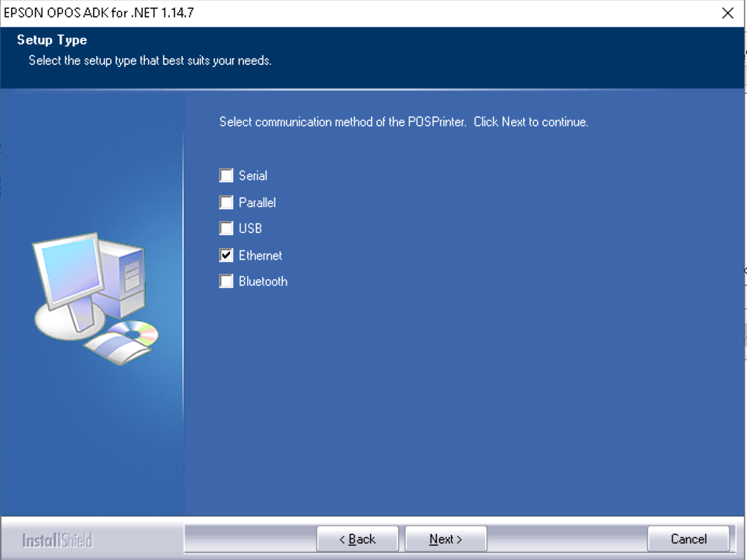
choose the appropriate communication of the printer, if use IP address to connect the printer, then choose ‘Ethernet’ , then click “Next >”

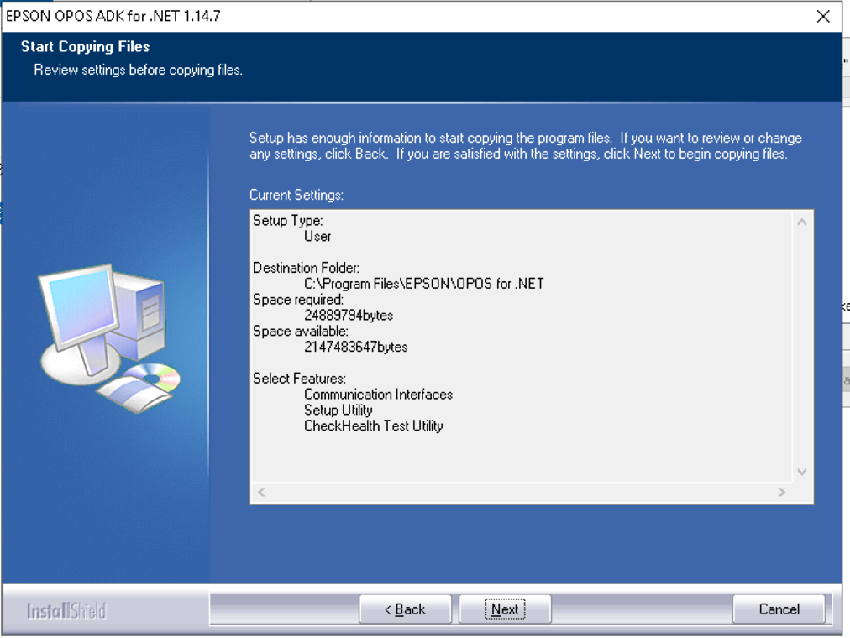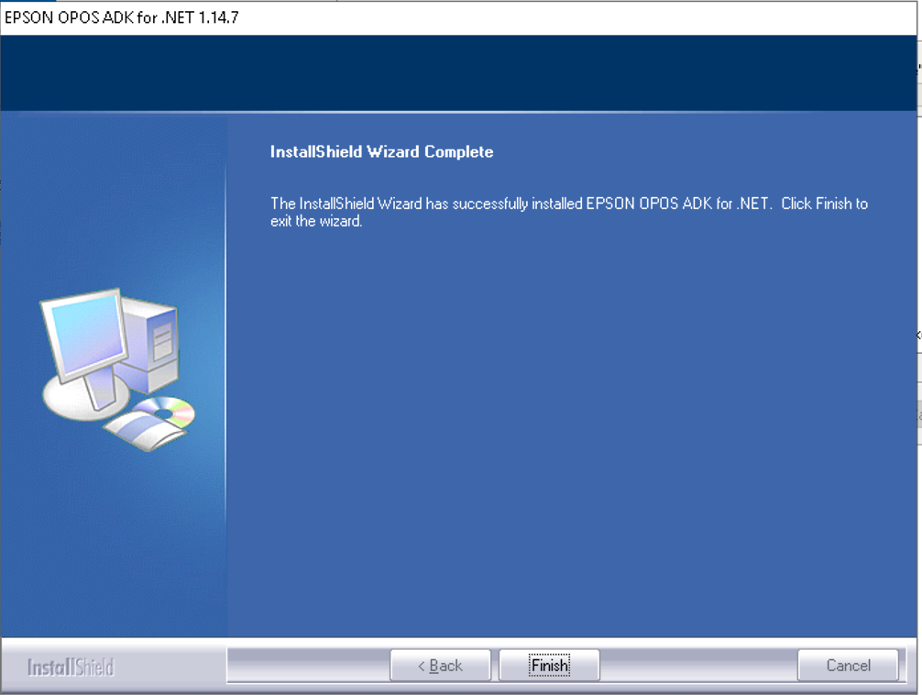
click “Next >”, click “Finish”
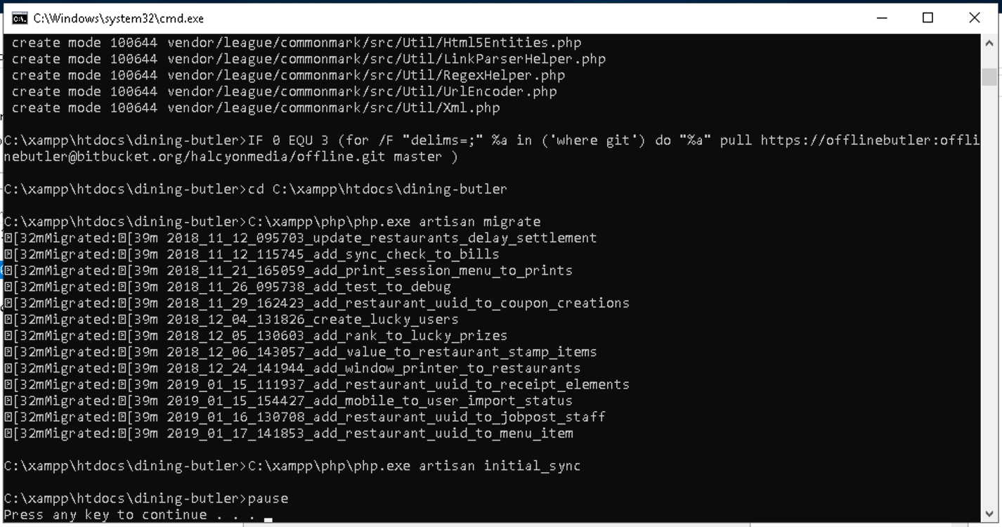
When there is command window as above screenshot, please don’t close the window !! Please wait until the process is finished. There will be a message ‘Press any key to continue…’ , After press any key, the window will be closed automatically.

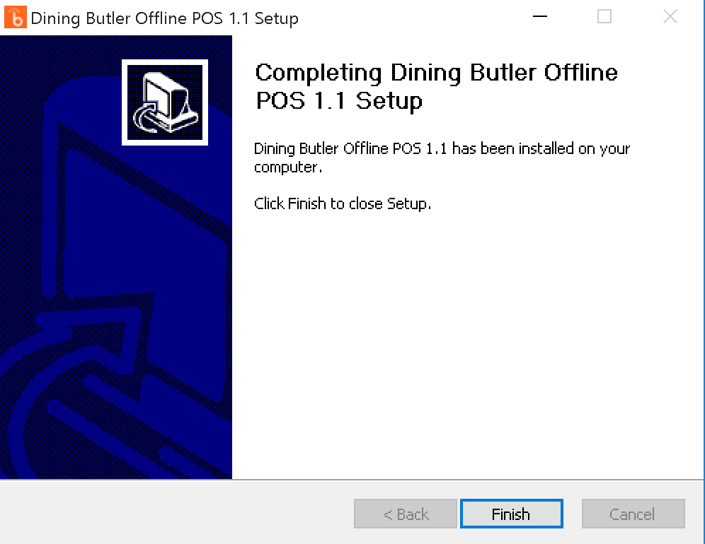
Click “Finish”

Check the installation by open the browser, go to POS url (e.g: http://192.168.0.100/pos)
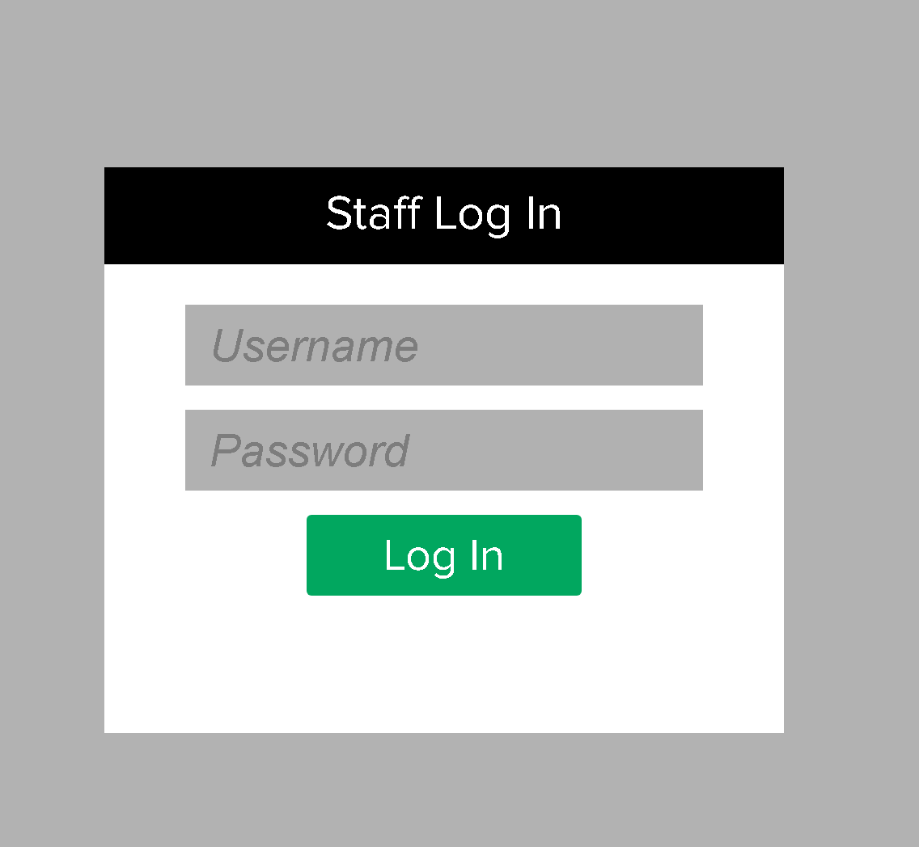

NOTE:
if you got error page on the browser, try to do initial_sync (e.g: http://192.168.0.100/initial_sync), then access the pos URL again

- Run SetupPOS
After installation finished, there will be shortcut in desktop ‘setupPOS’, click ‘setupPOS’ in the desktop.
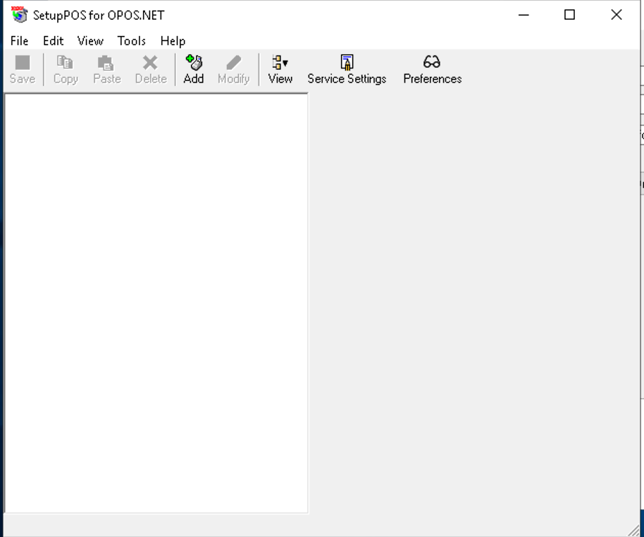
click “Add”
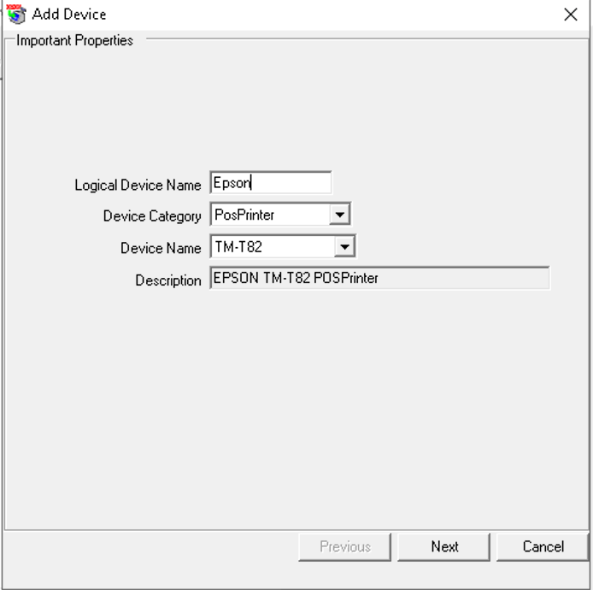
Fill in the printer name in the logical device name field (e.g: ‘Epson’), Note: the name should be the same with the backend. Choose Device Category ‘PosPrinter’, and choose the appropriate printer model. then click “Next”

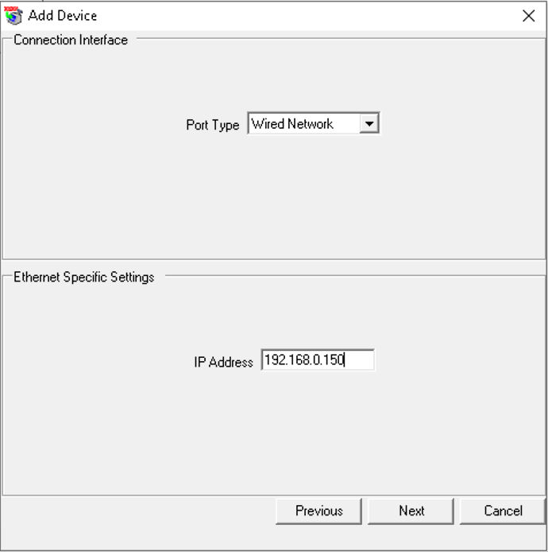
choose Port Type, if use IP Address to connect to the pritner, then choose ‘Wired Network’, and fill in the printer IP Address.

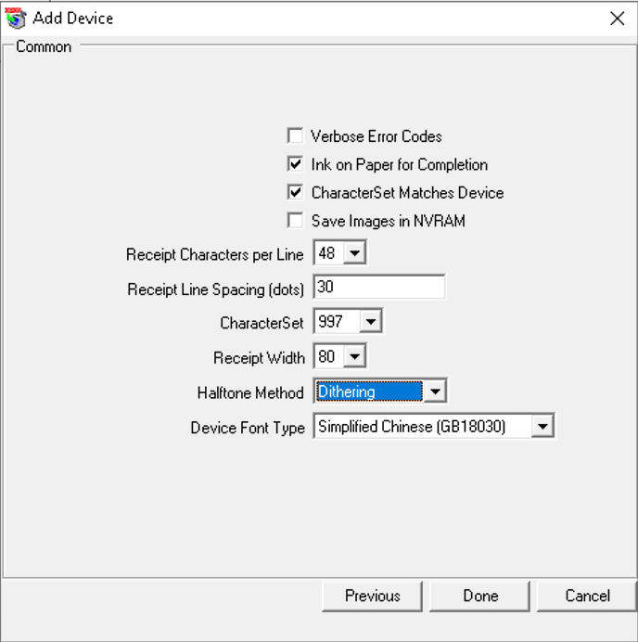
choose “Dithering” for Halftone Method, then click “Done”

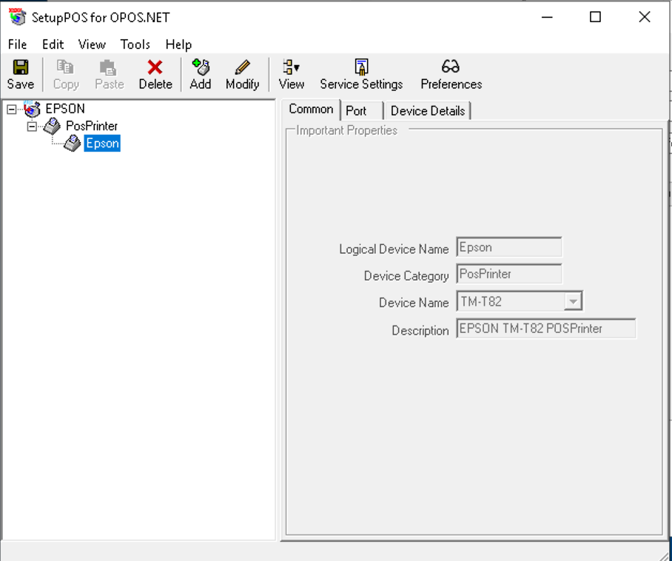
click “Save”.
to add CashDrawer, please repeat the process. for CashDrawer, Logical Device Name format should be ‘<printer_name>c’ (e.g: Epsonc) and Device Category is “CashDrawer”

- Run Windows Controller
Run windows controller, in C:\xampp\htdocs\WindowsController.exe. It will run on the minimized mode, you can click on bottom bar to display the window.
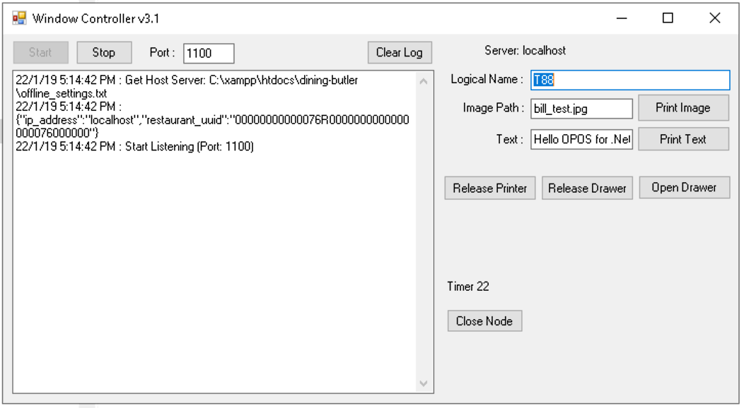

- Run WindowsController.exe on start up (set hidden)
- open Task Scheduler
- in Action right-panel, Click ‘Create Task’, and put Name (e.g: “offline_Sync”) and click ‘Hidden’ and ‘Run with highest privileges’
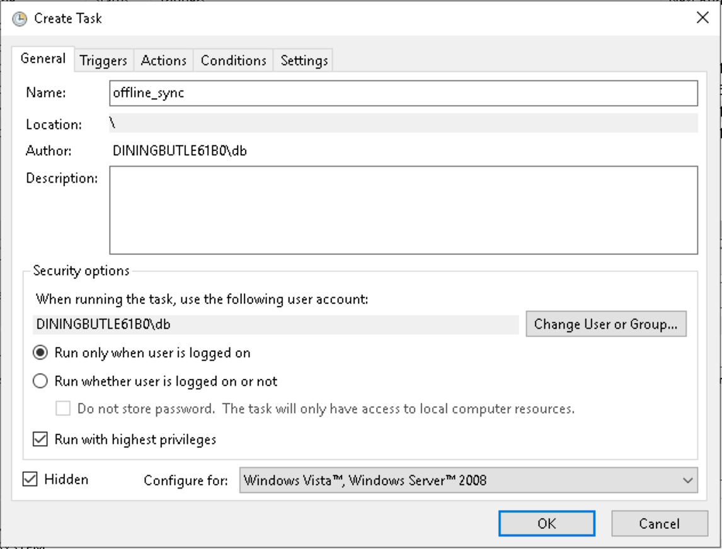

- On tab Triggers, click New… button,
- Choose “At log on”, then click “OK”
- On tab Actions, click New… button
- Browse windows controller location or just fill in C:\xampp\htdocs\WindowsController.exe on Program, then click OK
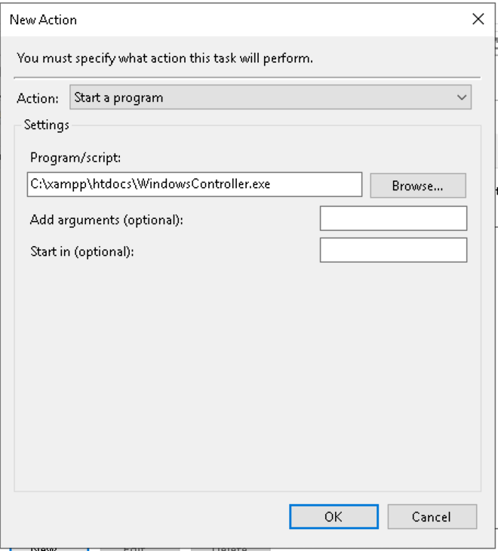

- Run Teamviewer on start up
- Run Teamviewer
- On menu Extras, choose Options
- On General section, click ‘Start TeamViewer with Windows’, put password as ‘admin123’ ,
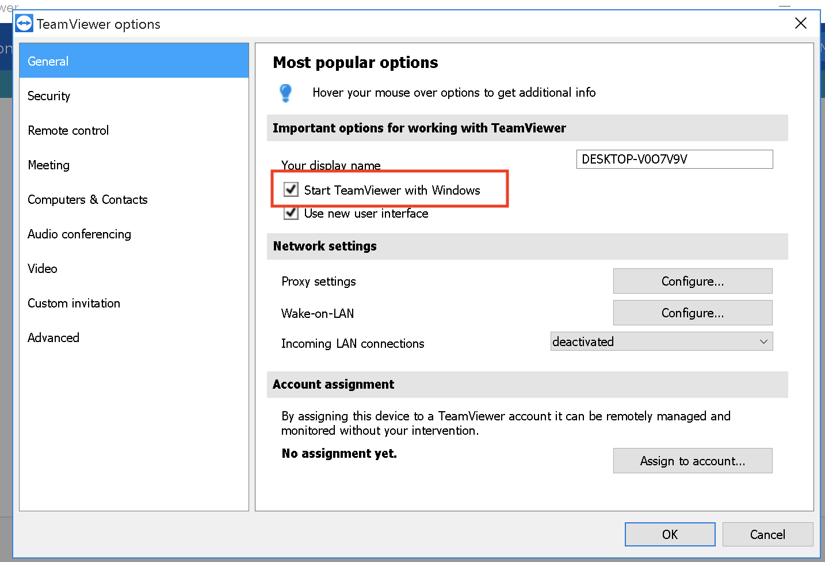
- Click ‘OK’

- Run chrome on start up with fullscreen
- open Task Scheduler
- in Action right-panel, Click ‘Create Task’, and put Name (e.g: “Startup_Chrome”) and click ‘Run with highest privileges’
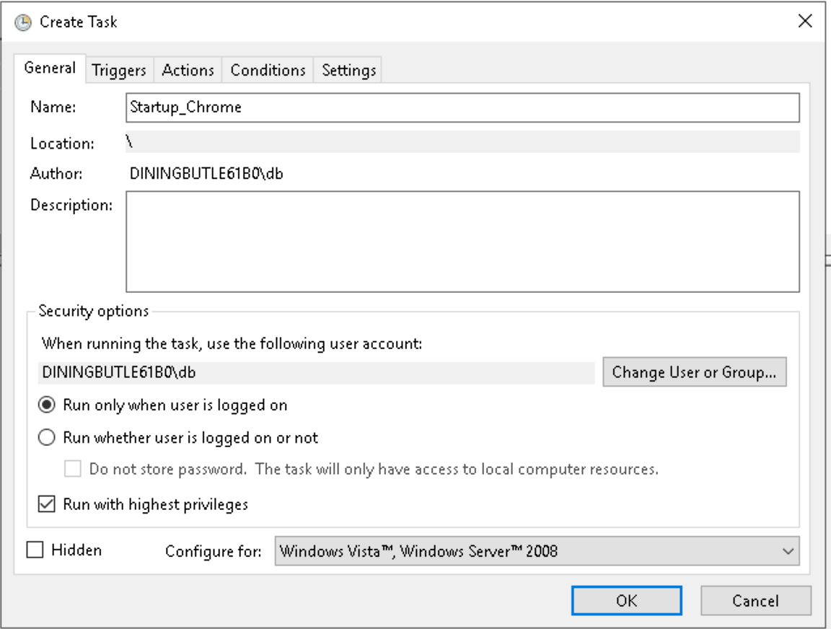

- On tab Triggers, click New… button,
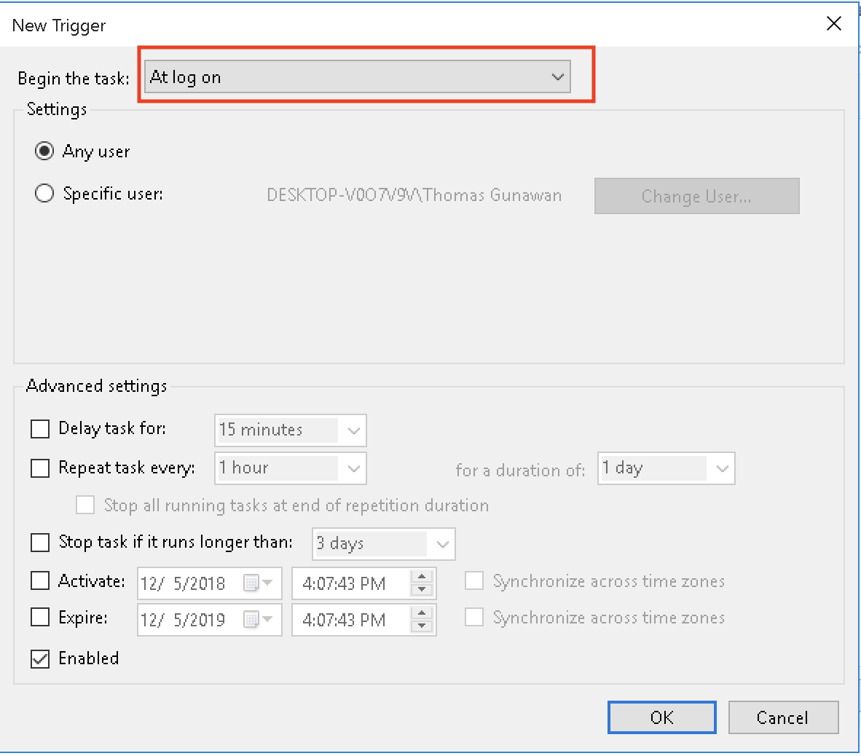
- Choose “At log on”, then click “OK”
- On tab Actions, click New… button,
- In Program field, put : C:\Program Files (x86)\Google\Chrome\Application\chrome.exe
- In ‘Add argument’ field, put : --start-fullscreen
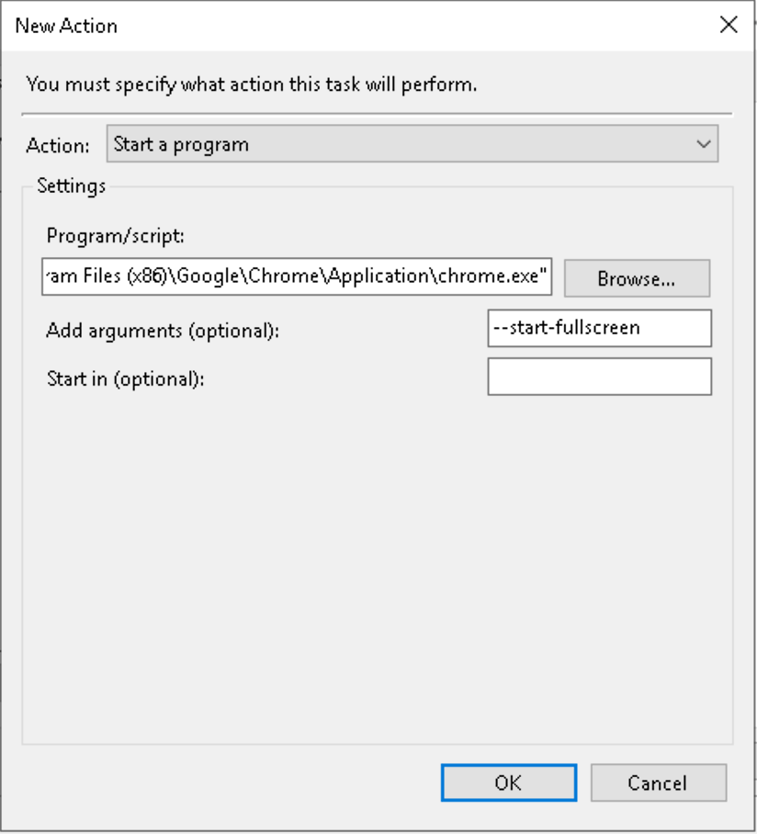
ix) click OK, then click OK again

- Set browser (chrome) start up page to pos URL
i) On your computer, open Chrome.
ii) At the top right, click More
iii) click Settings
iv) Under “On startup”, check “Open a spesific page or set of pages”
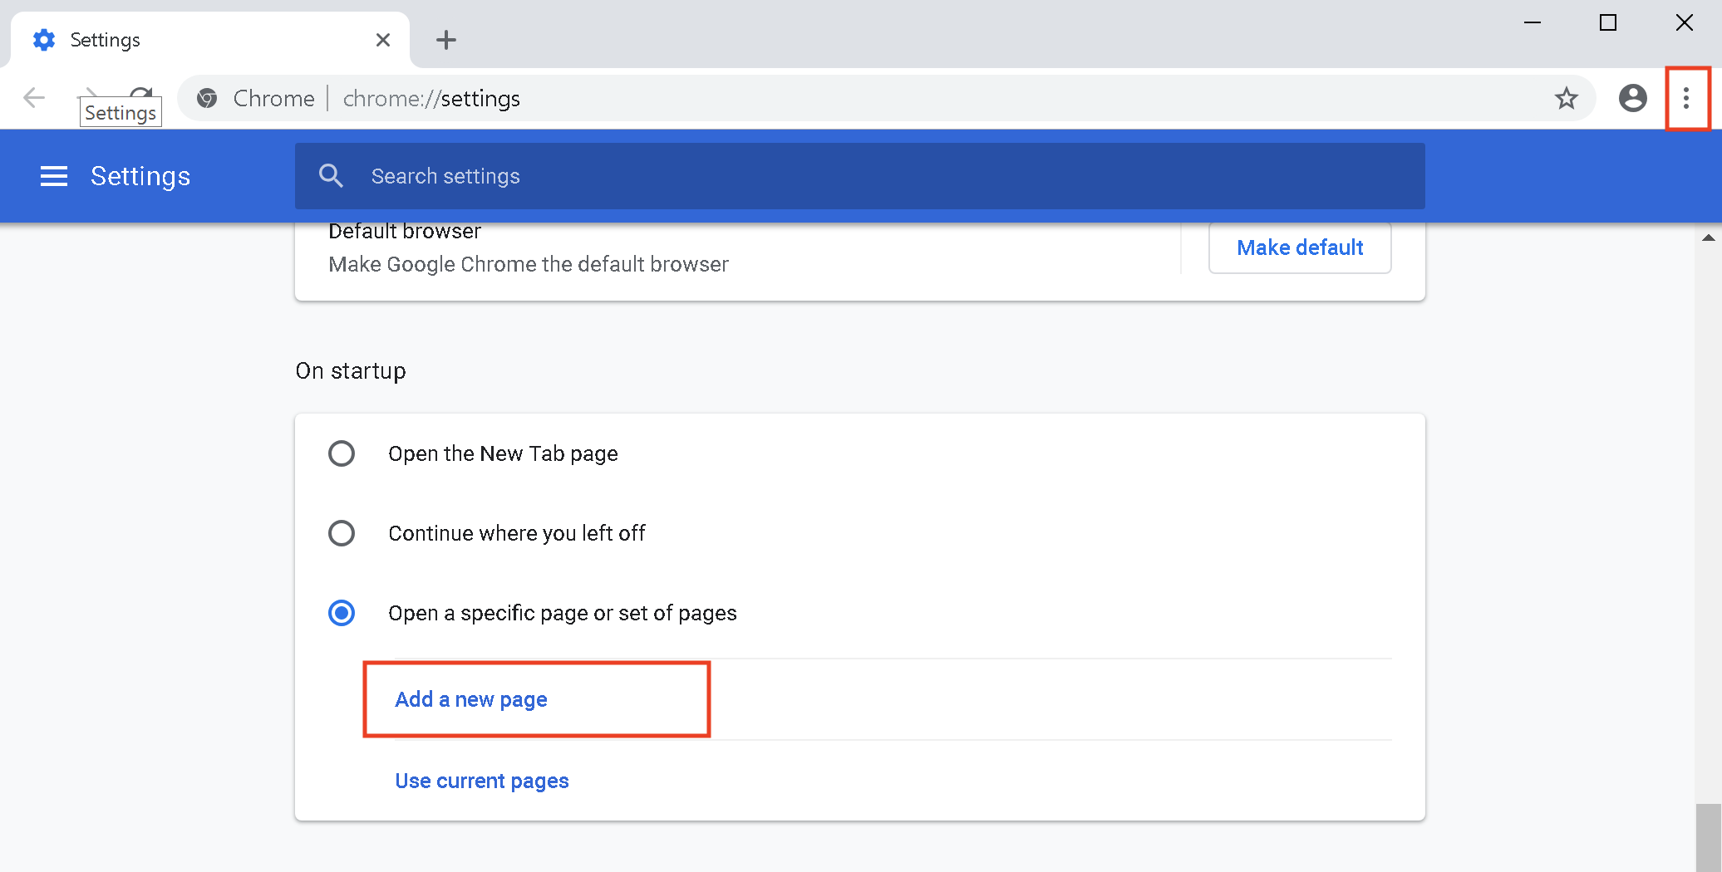
v) Click “Add a new page”, fill in the start up page to pos URL (e.g: http://192.168.0.100/pos)
vi) close the window

- Set chrome as default browser
i) On your computer, open Chrome.
ii) At the top right, click More
iii) click Settings
iv) in the “Default browser” section, click Make default

14. Done
Check the installation by restarting the computer. After restart, the full-screen browser should be appear with POS login page

